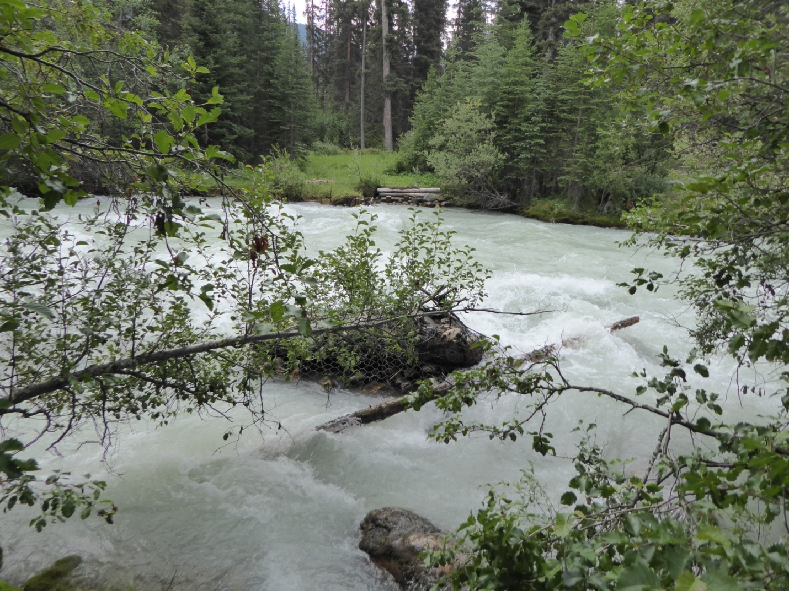
Simon Creek, at former bridge location
Athabasca Pass Trail

